**INTRODCTION**

Precept: The author is from New Jersey and is a member of the United Methodist Church of New Jersey

## Background

The governor of New Jersey, Phil Murphy, on May 9, 2019 recently singed a legislation to fight hunger in the state. The legislation signed addresses New Jersey’s hunger crisis by coordinating efforts between government agencies, including the Department of Agriculture, the Office of the Secretary of Higher Education, and the Office of the Chief Innovation Officer and private and social organizations.

It’s hard to believe that, in a country where 40 million people face hunger every day, so much food could go uneaten. Yet, this is precisely what is happening – and we’re all partially to blame. Perfectly good food is being wasted at every level of the supply chain: on the farm, during distribution, at the store, at the restaurants, and in our homes. In addition to the enormous humanitarian cost, our food waste epidemic is also an economic and environmental catastrophe.

According to a report from National Public Radio (NPR), a half a pound of food waste that is created per meal that is made in a restaurant, whether it’s from what is left on a customer’s plate, or in the kitchen itself. Approximately 85% of the food that isn’t used in a typical American restaurant is thrown out while only a small percentage is recycled or donated. With more than 42 million food insecure people in our country, this amount of food waste is obviously a major problem. Multiple ways to address this problem is being done but it has a long way to go, other means to address this problem are always encouraged. It is in this context that this analysis is done, i.e., the analysis is limited to what can be done restaurant food waste.

The United Methodist Church of Greater New Jersey (UMGNJ) is an active participant of social activities in the communities where they are present. They have long recognized the need to contribute to fight hunger. One way of doing so is that local churches, from time to time, offers free food the most vulnerable member of the society - the homeless. The program is mostly funded by financial contributions from its members. But with the dwindling membership and consequently less financial contribution, the frequency that it conducts these foods for the homeless is becoming less frequent.

## Problem/Issue

The Church see the need to continue the program at regular frequency, but it must find ways to source out food that will be served for the homeless. And, even perhaps extend it to other vulnerable members of the society by establishing food banks.

## **Proposition (Purpose)**

This analysis aims to give UMGNJ recommendations as to who and where are the possible restaurants that can contribute food to their cause, and where to set a pilot sites for food banks that will make the biggest impact and according to their church locations.

**DATA**

## **Data Sources**

A 2018 report, Point-In-Time Count of the Homeless in the New Jersey, conducted by Monarch Housing Associates lists the number of homeless people per county, and per town in the State. The towns with high concentration of homeless people are typically saddled with demographics that are below poverty line and struggling to their day to day living.

The state wide report for homeless persons is downloaded as a PDF file from : <https://cdn.monarchhousing.org/wp-content/uploads/njcounts18/2018PITReportStatewide.pdf>. This report lists the homeless counts for each county in the state.

The Essex County wide report for homeless persons is downloaded as a PDF file from : <https://cdn.monarchhousing.org/wp-content/uploads/njcounts18/2018PITReportEssex.pdf>. This report lists the homeless counts for each municipality in Essex county.

An example of the report is, note the report is in PDF so report needs to be scrapped in Python:

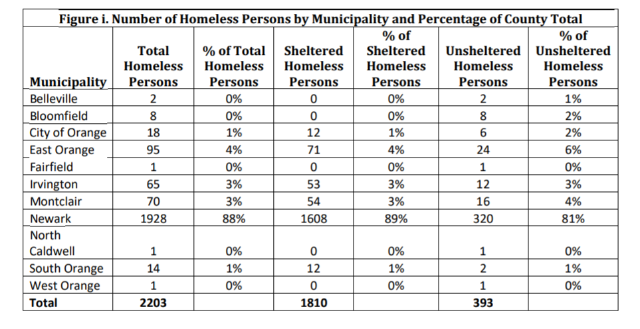

The UMCGNJ divided their presence in New Jersey into nine districts, the website list all the UMCGNJ churches the town and district where they belong. This data can be downloaded from their website, <https://www.gnjumc.org/districts/>, in XLS format. A screen shot of the xls file is shown below:

|  |  |  |  |
| --- | --- | --- | --- |
| **TOWN** | **CHURCH NAME** | **CHURCH NUMBER** | **DISTRICT** |
| DEPTFORD TWP | Almonesson UMC | 1001 | Gateway South |
| AUDUBON | Audubon UMC | 1002 | Gateway South |
| MANTUA TWP | Barnsboro UMC | 1003 | Gateway South |
| MANTUA TWP | Mt Zion UMC (Barnsboro) | 1004 | Gateway South |
| BARRINGTON | First UMC (Barrington) | 1005 | Gateway South |

Foursquare API gives a list of restaurants per neighborhood/location. Using data from the report, we can selectively identify restaurant that can potentially contribute to the food banks. The list will be clustered into groups so that collection efforts will be maximized and will also determine the number of food banks to be established.

**METHODOLOGY**

The following steps were taken in the analysis:

1. A table summarizing the count of homeless persons by NJ counties is scraped from the NJ statewide report on homeless persons (2018PITReportStatewide.pdf).
2. Convert the statewide table into a data frame, drop and rename columns for processing.
3. From the statewide data frame, determine what county has the largest homeless persons.
4. Download the homeless report for the county which has the highest homeless persons. In this case, its Essex County (2018PITReportEssex.pdf)
5. Similarly, scrape the PDF table from the county report that list homeless persons count by municipality/town.
6. Convert the county table into a data frame, drop and rename columns for processing.
7. From the county data frame, determine what municipality/town has the largest homeless persons.
8. Convert the xls file that lists the UMCGNJ into a data frame and identify the churches located in the town that has the highest homeless persons.
9. Clean the church list data frame. Add address for each church as the xls file does have the address
10. Using geolocator, identify the geographic coordinates of each church and add them to the church data frame.
11. Using the church geographic coordinates and Fourscore API request venues within 2000 meters from each church. Convert these venues into a venue data frame.
12. Filter the venue data frame such that only the venues that serves food are listed.
13. Apply clustering on the venues and identify the clustering key.
14. Iterate k values and determine the appropriate number of clusters.
15. Present/list the venues per cluster.

**RESULTS**

After data cleaning the NJ statewide homeless report, Essex County has the most homeless persons in the NJ with 2229 homeless persons. The county accounts for 24 percent of the statewide homeless count. And, after processing of the Essex County homeless report, not surprisingly the municipality of NEWARK came out as the town that has most homeless persons with 1928 persons, this is 87 percent of the Essex County homeless count and 20 percent of the statewide count.

|  |  |
| --- | --- |
|  |  |

Processing the UMCGNJ church list identified that there are four churches in NEWARK. Plotting them in a map shows that they are spread across NEWRAK

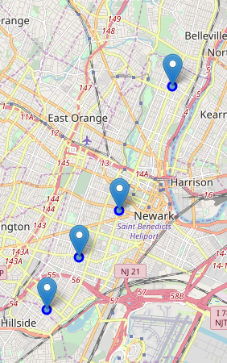

Using the Foursquare API and geographic coordinates of NEWARK returned 100 venues and 55 of these venues serves food (potential contributors to the food bank). The map shows where these 55 venues are in proximity to the church locations.

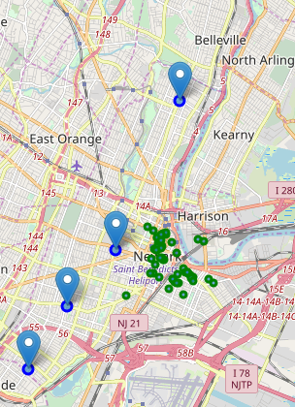

Using geographic coordinates of the churches returned 367 venues and 105 of these venues serves food (potential contributors to the food bank). The map shows where venues are in proximity to the church locations.

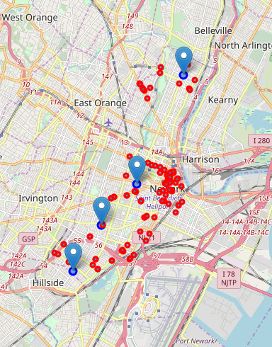

Clustering the venues group them according the Venue Category (i.e., Restaurants, Coffee Shop, Deli, Pizza)

With k = 4 the cluster were

Cluster 0 venue categories are various types Restaurant, BBQ joint, and Deli

Cluster 1 venue category is Coffee Shop

Cluster 2 venue category is Fast Food Places

Cluster 3 venue category is Pizza Place

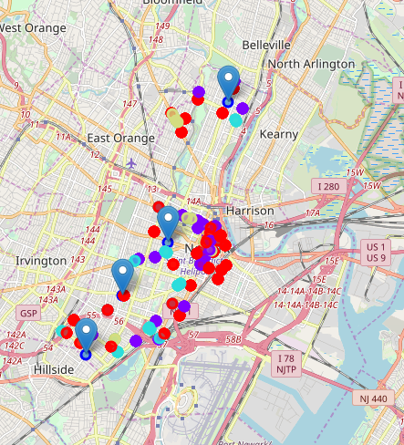

With k = 5 the cluster were

Cluster 0 venue categories are various types Restaurant, BBQ joint, and Deli

Cluster 1 venue category is Coffee Shop

Cluster 2 venue category is Fast Food Places

Cluster 3 venue category is Deli

Cluster 4 venue category is Pizza Place

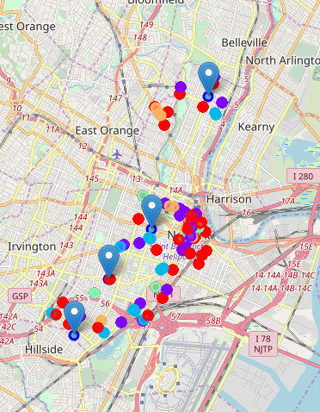

With k = 6 the cluster were

Cluster 0 venue categories are various types Restaurant, BBQ joint, and Deli

Cluster 1 venue category is Coffee Shop

Cluster 2 venue category is Deli

Cluster 3 venue category is Pizza Place

Cluster 4 venue category is Fast Food

Cluster 5 venue category is American Restaurant

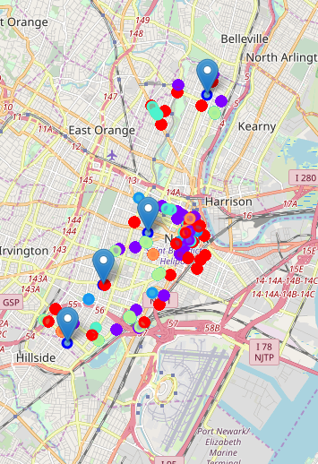

**DISCUSSION**

I initially get venues around the geographical coordinates of NEWARK. The request only returned 100 venues. This is a limitation of the Foursquare API, it limits the results to 100, does not matter if you literally put the limit (in the request) to 1000. Furthermore, the venues returned are within proximity to one church only, this is without surprise since we basically asked for venues based on NEWARK’s latitude and longitude. The resulting dataset of venues is not reflective of the venues across NEWARK, or specifically venues that are with proximity of the four UMCGNJ churches.

With this limitation is much better to use the dataset of venues surrounding the four churches in NEWARK. This makes more sense as the church themselves is where the food banks will be.

Clustering the different venues shows that the clustering discriminating value is based on the VENUE CATEGORY. This makes sense because collecting foods for the Food Bank will probably require different logistic for each type of VENUE CATEGORIES, i.e., handling of restaurant food is different from handing of deli foods, pizza, fast foods and so on. Food containers varies across the different VENUE CATEGORIES, and different collection time perhaps.

And with an initial k value 4, Cluster 0 mixed the different restaurants and deli places. This NOT does seem a good mix as Deli food types are typically cold cuts whereas restaurant foods can range the entire nine yards of food types. Clusters 1,2, and 3 are pretty much clear cut, with Coffee Shop, Fast Food Places, and Pizza Place, respectively.

With k = 5, the clustering is clear cut between boundaries of food types Restaurants/BBQ Joints, Deli Places, Coffee Shops, Pizza Place and Fast Foods.

With k = 6, American Restaurants has its own cluster in addition to clusters for Restaurants/BBQ Joints, Deli Places, Coffee Shops, Pizza Place and Fast Foods.

**CONCLUSION**

The churches of UMCGNJ in Newark (Franklin-St John's UMC, St Matthew's UMC, St Paul's Centenary UMC, Trinity UMC) will be used as Food Banks. There are 105 venues that cater to food services that can potentially be used to source out food for the Food Banks. The 105 venues will need to be clustered into 5 types of venue categories: Restaurants/BBQ Joints, Deli Places, Coffee Shops, Pizza Place and Fast Foods. The churches should consider the logistics to collect the foods from the different clusters.

Depending on their resources available, the churches can either collectively collect the foods from each cluster, i.e. the churches pool their resources and establish team(s) for each cluster.

Or each church can collect the foods from the venues in their neighborhood according to the cluster type